May 2022

Dear Friend of Saint Joseph the Worker Parish:

As you may be aware, the Festival at Saint Joseph the Worker has been a great success for decades. The Festival is a wonderful community event in Orefield and a tremendous fundraiser for our parish. With your help it will succeed once again. The Festival will take place this year from Friday – Sunday, June 17th-19th.
We hope that you can attend and maybe even spread the work for us in any way possible.

The Festival will continue to offer fun and fellowship for our parishioners and all our guests. This year we are also very excited to announce a big change in our Festival. We are turning it into an International Food Festival! Foods from all over the world will be offered. Although many of the favorites will still be offered, we are adding some new items to give a new flavor to our Festival.

We reach out to you at this time to seek your assistance as a patron/sponsor to our International Food Festival. We have found over the years that the sponsorship by our patrons/sponsors and local businesses has greatly added to the success of our Festivals. This year, we have no doubt, will be same. Businesses will have their logo prominently displayed on a banner under the band/dining tent. If you would like to be a patron/sponsor, please send your sponsorship form and business ad by May 25, 2022. Feel free to email both items if that makes it easier for you. Payment can be mailed to:
Saint Joseph the Worker Church
ATTN: FESTIVAL
1879 Applewood Drive
Orefield, PA. 18069

Feel free to contact us at the Parish Office (610-395-2876 or at: sponsors@stjwchurch.org) if you have any questions. Anne, our Parish Secretary, will be happy to assist you. You can scan the sponsorship form and your business ad and send it to the same email as well.

Thank you for your support! We look forward to hearing from you and we hope you’ll be able to join us for our International Food Festival.
Sincerely yours,
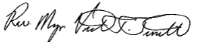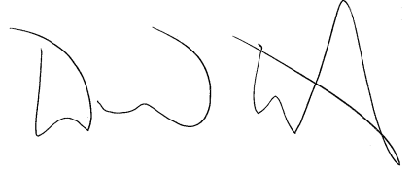
Reverend Monsignor Victor F. Finelli, V.J., J.C.L. Mr. David W. Abert
Pastor Festival Chair

